**Gantt Chart**

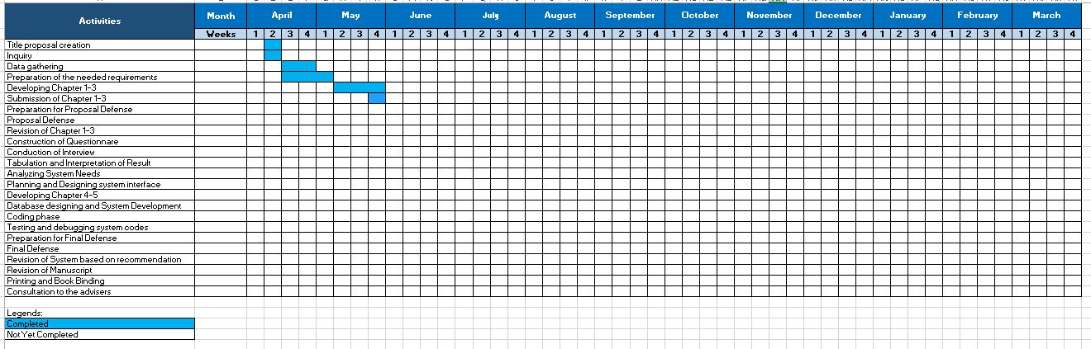

**Note: Gantt Chart should start from June 2018 to March 2019**

**Individual tasks**

|  |  |  |
| --- | --- | --- |
| **Activity** | **Description** | **Person responsible** |
| Brainstorming for possible SP topic/s | Conducting research for possible topics |  |
| Title Defense | Presentation of the client and proposed title to the professor |  |
| Data Gathering | Asking the client of the certain data which is given by the professor during the title defense |  |
| Revision of the title proposal | Revised the title of the proposed project |  |
| Developing the Chapter 1 - 3 | Making an individual research for the info. needed |  |
| Summarize Chapter 1 | Summarizing Chapter 1 by the using of the data gathered |  |
| Researcher for Chapter 2 | Searching for the related foreign and local: (literature and studies) |  |
| Adding an important requirements on Chapter 3 | Supplying more data requirements on chapter 33 |  |
| Finalize Chapter 1 - 3 | Making a review on the details of information |  |
| Proposal Defense Presentation | Prepare PowerPoint Presentation |  |

Tasking can be based on your gantt chart or methodology

User Interface design

